SIMATS ENGINEERING (SAVEETHA SCHOOL OF ENGINEERING)
Department of Computer Science and Engineering

ASSESSMENT TOOL 1 – EXPERIMENTS

Course Code: | CSA06 | Course Title: | Design and Analysis of Algorithms
CO Assessed: | CO3: Experiments (BL4, BL5) | Assessment: | Assessment Tool 1 – Experiments
Weightage: | 40% of CIA | Total Marks: | 100 (2 Questions × 50 Marks)
CO3 Statement: | Design Divide and Conquer algorithms for Merge Sort, Quick Sort, Binary Search and Matrix Multiplication
Student Name: | Lella Thannveer Reddy | Reg. No.: | 192524293
Section / Batch: | Slot - A | Date: | 12/08/2026

Instructions to Students
- Write algorithm and execute code both experiments.
- Each questions 50 Marks. Total: 100 Marks.
- Follow a well-structured, systematic approach to design and implement an optimal solution.
- Provide insightful analysis with accurate validation, supported by clear documentation including diagrams, code, and results.

Question Type | Description | Questions | Total Marks
Experiments | Design and Code for Divide and Conquer  Algorithms: Merge Sort, Quick Sort,  Binary Search, and Matrix Multiplication | Q1 – Q2 | 100

SECTION A – Experiments

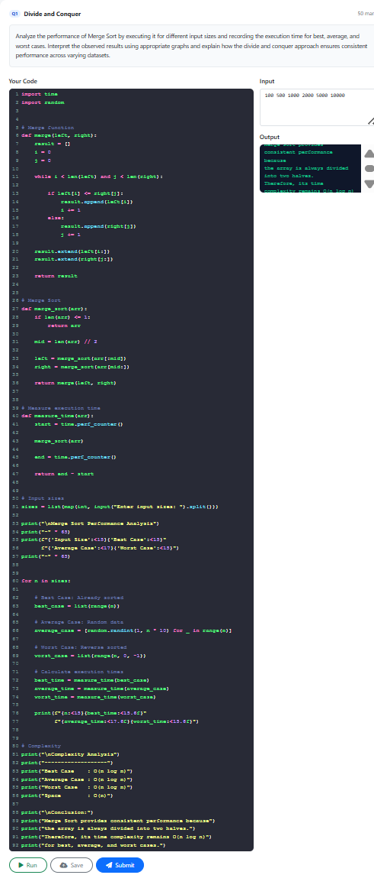
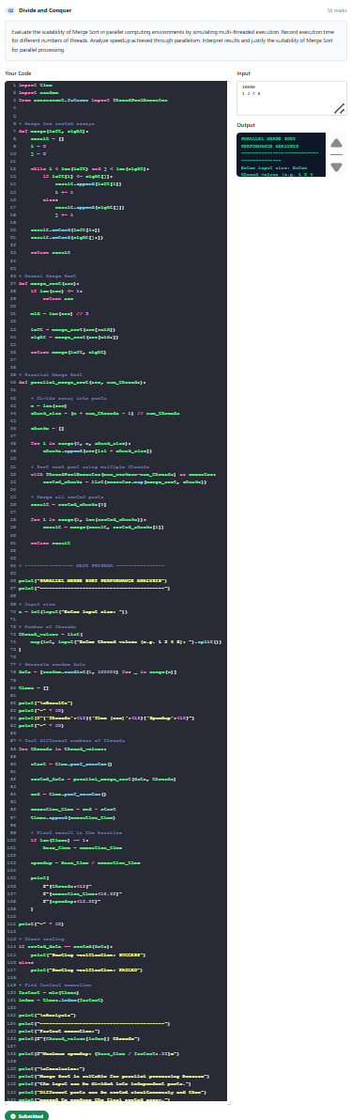

Code of Conduct
I _Lella Thannveer Reddy/192524293_ (Name / Reg No) certify that this submission is my original work and that I have adhered to the guidelines specified for this assessment. I understand that any violation of academic integrity rules will result in disciplinary action.
Signature of the Student: 

RUBRICS FOR CALCULATION

Experiments
Criteria | Weigh tage | Level 4 –  Exemplary | Level 3 –  Proficient | Level 2 –  Developing | Level 1 –  Beginning
Understand ing of  Concepts | 25 | Demonstrates thorough  understanding and  effectively integrates multiple concepts/technologies | Good understanding with proper  integration of most concepts | Basic understanding;  limited or partial integration | Poor understanding  ; unable to integrate concepts
Experimen tal Design | 30 | Well-planned, systematic  implementation with optimal solution | Correct implementatio  n with minor issues | Basic implementation with errors or inefficiencies | Incorrect or incomplete  implementatio  n
Use of Tools | 20 | Effective and advanced use of  tools/technologies with proper configuration | Appropriate use of tools  with correct execution | Limited or inconsistent use of tools | Incorrect or minimal use of tools
Analysis of Results | 15 | Insightful analysis with accurate  interpretation and validation of results | Good analysis with  reasonable interpretation | Basic analysis with limited insights | Poor or incorrect analysis of results
Documenta  tion | 10 | Clear, well-structured documentation with diagrams, code, and  results | Organized documentation with necessary details | Basic documentation  with missing details | Poor or incomplete  documentatio  n
Marks Evaluation:
Experiments | Understanding of  Concepts  (25) | Experimental  Design  (30) | Use of Tools  (20) | Analysis of  Results  (15) | Documenta  tion  (10) | Total  Marks  (Each - 50)
Ex. 1
Ex. 2
 |  |  |  | Overall Total (100) |  | 100 %

Faculty In-charge | Course Coordinator | Head of Department
Name: __________________  Signature: _______________ | Signature: _______________ | Signature: _______________
Date: ___________________ | Date: ___________________ | Date: ___________________

